6.53: a) In terms of the acceleration a and the time t since the force was applied, the speed is 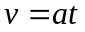 and the force is ma, so the power is 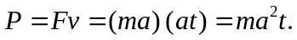 b) The power at a given time is proportional to the square of the acceleration, tripling the acceleration would mean increasing the power by a factor of nine. c) If the magnitude of the net force is the same, the acceleration will be the same, and the needed power is proportional to the time. At 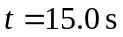, the needed power is three times that at 5.0 s, or 108 W.

